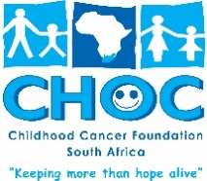
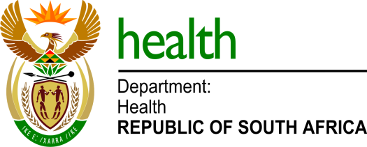
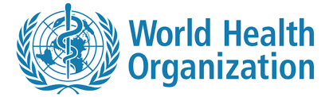

MEDIA STATEMENT

To: Health Editors & Journalists
Issued by: Departments of Health
Date: Tuesday, 14 February 2023

International Childhood Cancer Day – 15 February

Pretoria: South Africa will tomorrow (Wednesday) join the global community to observe the International Childhood Cancer Day to raise awareness and improve understanding of childhood cancer, which remains one of the leading causes of death in high-income countries amongst children under the age of 15.

Although childhood cancer is relatively rare, the incidence rate has been increasing which may be due to awareness. Almost 400 000 children are diagnosed annually, and South Africa accounts for almost 1500 of this global number. Many children with cancer in low-and-middle-income countries are either not diagnosed on time or referred too late for curative care. One of the contributing factors for this, is a lack of awareness and knowledge of the early warning signs.

The most common types of childhood cancers include leukaemia, lymphoma, brain, kidney and eye tumours.

The Department of Health working together with the South African Children’s Cancer Study Group and CHOC Childhood Cancer Foundation South Africa have initiated a programme to disseminate information to empower the communities with knowledge about the early warning signs and the unique and complex challenges faced by children with cancer and their families. They also endeavour to offer support all children during their arduous journey.

The World Health Organization, governments, civil society organisations and health care workers are in partnership to meet the WHO Global Initiative for Childhood Cancer (GICC) goals of a 60% overall survival in children and adolescents with cancer in low-and middle-income countries by 2030.

International Childhood Cancer Day is observed annually across the world on February 15, and the 2023 campaign is observed under the theme: #ThroughTheirHands, which focusses on paying tribute to the families and caregivers, and the positive impact they have on the lives of children and adolescents living with cancer.

The community, parents and caregivers are urged to familiarise themselves with the Siluan Early Warning Signs (https://choc.org.za/childhood-cancer-early-warning-signs/).

For more information and media enquiries, please contact:

Mr Foster Mohale  Health Departmental Spokesperson  0724323792  Foster.mohale@health.gov.za | Mr Hedley Lewis  CHOC Childhood Cancer Foundation SA CEO  0829947655  Hedley.lewis@choc.org.za | Professor Gita Naidu  Chair SSACCSG  gita.naidu@wits.ac.za

